# LAMPIRAN – LAMPIRAN

Lampiran 1:

Potongan *Source Code* (Upload.php)

Dibawah ini adalah script menu upload artikel pada aktor user

|  |
| --- |
| <?php  session_start();  if (!isset($_SESSION['username'])) {  header("Location: ../index.php");  }  include "../assets/script.php";  include "../assets/header.php";  include "../assets/sidebar_user.php";  include "../koneksi.php";  $dir_artikel = "/uploaded_file/artikel/";  $dir_biopeng = "/uploaded_file/biopeng/";  $dir_skppi = "/uploaded_file/skppi/";  if (isset($_POST['submit'])) {  $id_user = $_SESSION['id_user'];  $judul_artikel = $conn->real_escape_string($_POST['judul_artikel']);  $nama_jurnal = $conn->real_escape_string($_POST['nama_jurnal']);  $kriteria_1 = $conn->real_escape_string($_POST['form_kriteria_1']);  $kriteria_2 = $conn->real_escape_string($_POST['form_kriteria_2']);  $url_sinta = $conn->real_escape_string($_POST['url_sinta']);  $url_scopus = $conn->real_escape_string($_POST['url_scopus']);  $url_artikel = $conn->real_escape_string($_POST['url_artikel']);  $kontribusi = $conn->real_escape_string($_POST['form_kontribusi']);  $lembaga_pengindeks = $conn->real_escape_string($_POST['lembaga_pengindeks']);  $tanggal_upload = $conn->real_escape_string($_POST['tanggal_upload']);  $upload_artikel = $dir_artikel . str_replace(' ', '-', $_FILES['upload_artikel']['name']);  $name_artikel = str_replace(' ', '-', $_FILES['upload_artikel']['name']);  $upload_artikel_tmp = $_FILES['upload_artikel']['tmp_name'];  $upload_biopeng = $dir_biopeng . str_replace(' ', '-', $_FILES['upload_biopeng']['name']);  $name_biopeng = str_replace(' ', '-', $_FILES['upload_biopeng']['name']);  $upload_biopeng_tmp = $_FILES['upload_biopeng']['tmp_name'];  $upload_skppi = $dir_skppi . str_replace(' ', '-', $_FILES['upload_skppi']['name']);  $name_skppi = str_replace(' ', '-', $_FILES['upload_skppi']['name']);  $upload_skppi_tmp = $_FILES['upload_skppi']['tmp_name'];  $artikelStatus = move_uploaded_file($upload_artikel_tmp, realpath(dirname(getcwd())) . $upload_artikel);  $biopengStatus = move_uploaded_file($upload_biopeng_tmp, realpath(dirname(getcwd())) . $upload_biopeng);  $skppiStatus = move_uploaded_file($upload_skppi_tmp, realpath(dirname(getcwd())) . $upload_skppi);  if ($artikelStatus && $biopengStatus && $skppiStatus) {  $select_data = "SELECT tanggal_awal , tanggal_akhir, id_periode FROM tb_periode";  $res = mysqli_query($conn, $select_data);  // $res = mysqli_fetch_assoc($res);  $temp_waktu = array();  foreach ($res as $waktu) {  $batas_awal = $waktu['tanggal_awal'];  $label_awal = 0;  $batas_akhir = $waktu['tanggal_akhir'];  $label_akhir = 1;  $id_periode = $waktu['id_periode'];  array_push($temp_waktu, array($label_awal => $batas_awal, $label_akhir => $batas_akhir, 2 => $id_periode));  // var_dump($waktu);  }  $status = false;  $last_id = 0;    date_default_timezone_set("Asia/Bangkok");  $temp_now = date("Y-m-d h:i:s");  // var_dump($temp_now);  for ($i=0; $i < sizeof($temp_waktu); $i++) {  $awal = $temp_waktu[$i][0];  $akhir = $temp_waktu[$i][1];  // echo $awal . " - " . $akhir;  // echo "<br>";  if($temp_now >= $awal && $temp_now <= $akhir){  $status = true;  $last_id = $temp_waktu[$i][2];  break;  } else {  $status = false;  }  }  if ($status == false){  echo "  <script>  alert('Periode Pengajuan Anda tidak sesuai dengan Periode Pengajuan Artikel');  document.location.href='upload.php';  </script>  ";  }  else{  $sql = "INSERT INTO tb_artikel (id_periode, id_user, url_sinta, url_scopus, kontribusi, judul_artikel, nama_jurnal, kriteria_satu, kriteria_dua, url_artikel, lembaga_pengindeks, upload_artikel, upload_biopeng, upload_skppi, status, tanggal_upload)  VALUES ('$last_id','$id_user', '$url_sinta', '$url_scopus', '$kontribusi', '$judul_artikel', '$nama_jurnal', '$kriteria_1', '$kriteria_2', '$url_artikel', '$lembaga_pengindeks', '$name_artikel', '$name_biopeng', '$name_skppi', 'pengajuan', CURRENT_DATE())";    if ($conn->query($sql) == TRUE) {  echo "  <script>  alert('Artikel berhasil ditambahkan');  document.location.href='cek_upload.php';  </script>  ";  } else {  echo "  <script>  alert('Artikel gagal ditambahkan');  </script>";  echo "<br>";  }  }  } else {  echo "Artikel :" . $artikelStatus;  echo "<br> Biopeng :" . $biopengStatus;  echo "<br> SKPPI :" . $skppiStatus;  echo "Gagal Upload";  }  } |

* 1. Potongan *Source Code (pengajuan.php)*

Dibawah ini adalah script menu data pengajuan insentif pada aktor admin

|  |
| --- |
| <?php  session_start();  if (!isset($_SESSION['username'])) {  unset($_SESSION['username']);  unset($_SESSION['id_user']);  unset($_SESSION['level']);  header("Location: ../index.php");  } else {  if (strcmp($_SESSION["level"], 'admin') != 0) {  unset($_SESSION['username']);  unset($_SESSION['id_user']);  unset($_SESSION['level']);  header("Location: ../index.php");  }  }  include "../assets/header.php";  include "../assets/sidebar_admin.php";  include "../koneksi.php";  $sql = "SELECT * FROM tb_jurusan";  $result_tb_jurusan = $conn->query($sql);  $sql = "SELECT * FROM tb_prodi";  $result_tb_prodi = $conn->query($sql);  $array_jurusan = array();  $i = 0;  while ($data = $result_tb_jurusan->fetch_array()) {  $array_jurusan[$i] = $data;  $i++;  }  $array_prodi = array();  $i = 0;  while ($data = $result_tb_prodi->fetch_array()) {  $array_prodi[$i] = $data;  $i++;  }  ?>  <!-- Ionicons -->  <link rel="stylesheet" href="https://code.ionicframework.com/ionicons/2.0.1/css/ionicons.min.css">  <!-- DataTables -->  <link rel="stylesheet" href="../lte/plugins/datatables-bs4/css/dataTables.bootstrap4.css">  <!-- Content Header (Page header) -->  <div class="container-fluid">  <div class="row mb-2">  <div class="col-sm-8">  <h3>Data Pengajuan Insentif Jurnal Dosen</h3>  </div>  </div>  </div>  <!-- /.container-fluid -->  <!-- Main content -->  <div class="container">  <div class="row">  <div class="card col-md-12">  <!-- /.card-header -->  <div class="card-body">  <table id="example2" class="table">  <thead>  <tr>  <th>No</th>  <th>Nama Dosen</th>  <th>NIDN</th>  <th>Jurusan</th>  <th>Prodi</th>  <th>Judul Artikel</th>  <th>Status</th>  <th>Aksi</th>  </tr>  </thead>  <tbody>  <?php  $data_artikel = mysqli_query($conn, "SELECT * FROM tb_user a JOIN tb_artikel b ON a.id_user = b.id_user WHERE b.status = 'pengajuan' OR b.status = 'proses'");  $i = 1;  foreach ($data_artikel as $data) {  ?>  <tr>  <td><?= $i++ ?></td>  <td><?= $data['nama_lengkap'] ?></td>  <td><?= $data['nidn'] ?></td>  <td><?php  for ($a = 0; $a < count($array_jurusan); $a++) {  if (strcmp($array_jurusan[$a]['id_jurusan'], $data['id_jurusan']) == 0) {  echo $array_jurusan[$a]['nama_jurusan'];  }  }  ?></td>  <td><?php  for ($b = 0; $b < count($array_prodi); $b++) {  if (strcmp($array_prodi[$b]['id_prodi'], $data['id_prodi']) == 0) {  echo $array_prodi[$b]['nama_prodi'];  }  }  ?></td>  <td><?= $data['judul_artikel'] ?></td>  <td><?= $data['status'] ?></td>  <td>  <div class="btn-group">  <a href="edit_artikel.php?id=<?= $data['id_artikel']; ?>" class="btn btn-success mb-2">Edit Status</a> &nbsp;  <a href="hapus_artikel.php?id=<?= $data['id_artikel']; ?>" class="btn btn-danger mb-2" onClick="return confirm ('Apakah anda yakin menghapus data yang dipilih?')">Delete</a>  </div>  </td>  </tr>  <?php } ?>  </tbody>  </table>  </div>  </div>  <!-- /.card-body -->  </div>  </div>  </div>  <!-- ./wrapper -->  <!-- jQuery -->  <script src="../lte/plugins/jquery/jquery.min.js"></script>  <!-- Bootstrap 4 -->  <script src="../lte/plugins/bootstrap/js/bootstrap.bundle.min.js"></script>  <!-- DataTables -->  <script src="../lte/plugins/datatables/jquery.dataTables.js"></script>  <script src="../lte/plugins/datatables-bs4/js/dataTables.bootstrap4.js"></script>  <!-- AdminLTE App -->  <script src="../lte/dist/js/adminlte.min.js"></script>  <!-- AdminLTE for demo purposes -->  <script src="../lte/dist/js/demo.js"></script>  <!-- page script -->  <script>  $(function() {  $("#example1").DataTable();  $('#example2').DataTable({  "paging": true,  "lengthChange": true,  "searching": true,  "ordering": true,  "info": true,  "autoWidth": true,  });  });  </script> |

* 1. Potongan *Source Code (data_periode.php)*

Dibawah ini adalah script menu data periode pengajuan pada aktor admin

|  |
| --- |
| <?php  session_start();  if (!isset($_SESSION['username'])) {  unset($_SESSION['username']);  unset($_SESSION['id_user']);  unset($_SESSION['level']);  header("Location: ../index.php");  } else {  if (strcmp($_SESSION["level"], 'admin') != 0) {  unset($_SESSION['username']);  unset($_SESSION['id_user']);  unset($_SESSION['level']);  header("Location: ../index.php");  }  }  include "../assets/header.php";  include "../assets/sidebar_admin.php";  include "../koneksi.php";  ?>  <!-- Ionicons -->  <link rel="stylesheet" href="https://code.ionicframework.com/ionicons/2.0.1/css/ionicons.min.css">  <!-- DataTables -->  <link rel="stylesheet" href="../lte/plugins/datatables-bs4/css/dataTables.bootstrap4.css">  <!-- Content Header (Page header) -->  <div class="container-fluid">  <div class="row mb-2">  <div class="col-sm-8">  <h3>Data Periode Pengajuan Insentif</h3>  </div>  <div class="col-sm-12">  <a href="tambah_periode.php" class="btn btn-primary mb-2 float-right">Tambah Periode</a>  </div>  </div>  </div>  <!-- /.container-fluid -->  <!-- Main content -->  <div class="container">  <div class="row">  <div class="card col-md-12">  <!-- /.card-header -->  <div class="card-body">  <table id="example2" class="table">  <thead>  <tr>  <th>No</th>  <th>Periode</th>  <th>Keterangan</th>  <th>Tanggal Mulai</th>  <th>Tanggal Berakhir</th>  <th>Aksi</th>  </tr>  </thead>  <tbody>  <?php  $data_periode = mysqli_query($conn, "SELECT * FROM tb_periode");  $i = 1;  foreach ($data_periode as $data) {  ?>  <tr>  <td><?= $i++ ?></td>  <td><?= $data['nama_periode'] ?></td>  <td><?= $data['keterangan'] ?></td>  <td><?= $data['tanggal_awal'] ?></td>  <td><?= $data['tanggal_akhir'] ?></td>  <td>  <div class="btn-group">  <a href="edit_periode.php?id=<?php echo $data['id_periode']; ?>" class="btn btn-success mb-2">Edit</a> &nbsp;  <a href="hapus_periode.php?id=<?php echo $data['id_periode']; ?>" class="btn btn-danger mb-2" onClick="return confirm ('Apakah anda yakin menghapus data yang dipilih?')">Delete</a>  }  <!-- /.card-body -->  <!-- ./wrapper -->  <!-- jQuery -->  <script src="../lte/plugins/jquery/jquery.min.js"></script>  <!-- Bootstrap 4 -->  <script src="../lte/plugins/bootstrap/js/bootstrap.bundle.min.js"></script>  <!-- DataTables -->  <script src="../lte/plugins/datatables/jquery.dataTables.js"></script>  <script src="../lte/plugins/datatables-bs4/js/dataTables.bootstrap4.js"></script>  <!-- AdminLTE App -->  <script src="../lte/dist/js/adminlte.min.js"></script>  <!-- AdminLTE for demo purposes -->  <script src="../lte/dist/js/demo.js"></script>  <!-- page script -->  <script>  $(function() {  $("#example1").DataTable();  $('#example2').DataTable({  "paging": true,  "lengthChange": true,  "searching": true,  "ordering": true,  "info": true,  "autoWidth": true,  });  });  </script>  <?php  include "../assets/footer.php";  ?> |

Lampiran 2 : Kuisioner

* + Responden untuk Aktor Super Admin

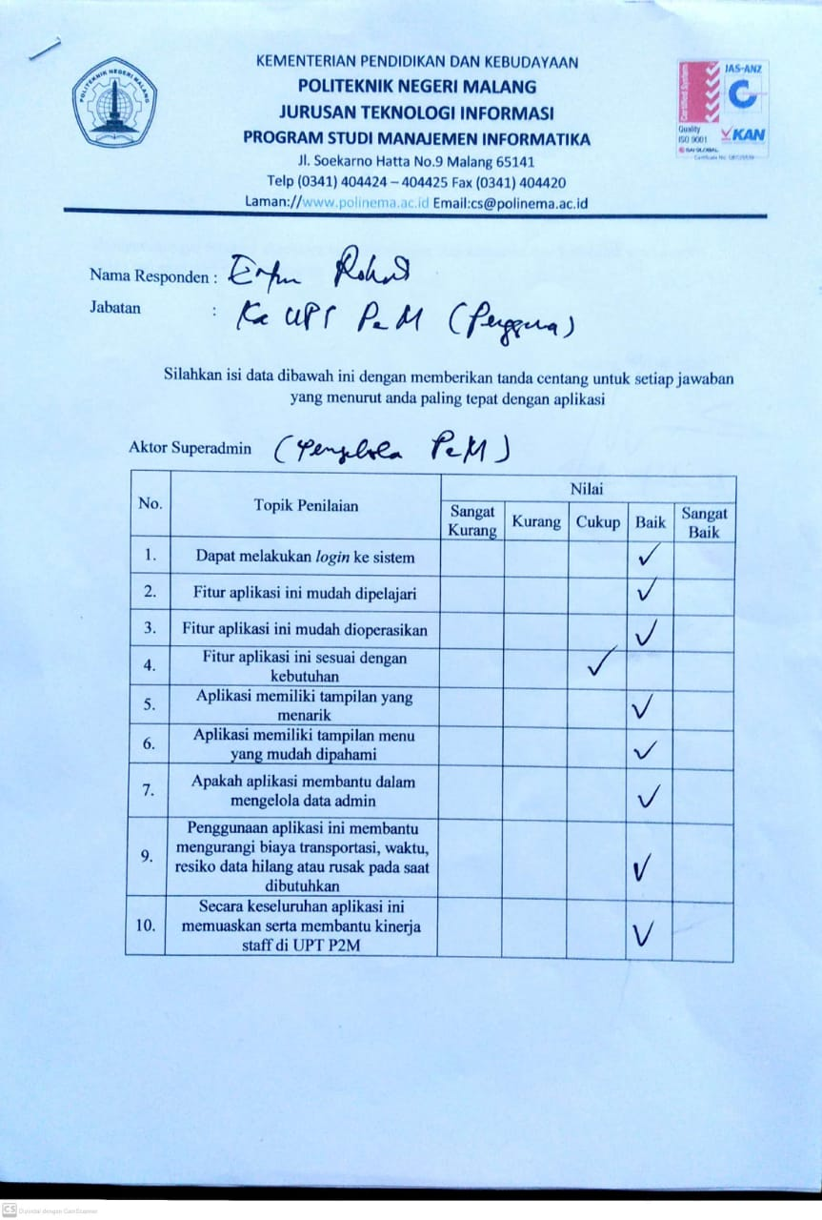



* + Responden untuk Aktor Admin

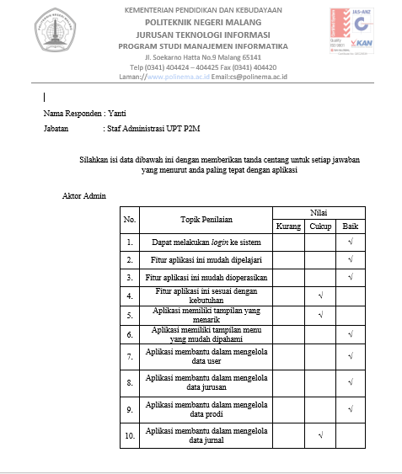

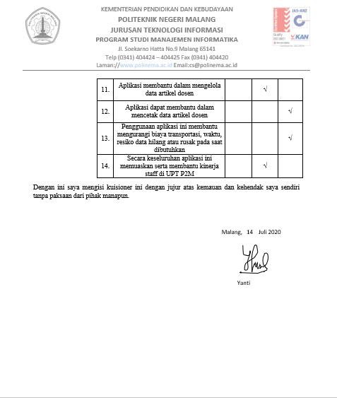

* + Responden untuk Aktor User

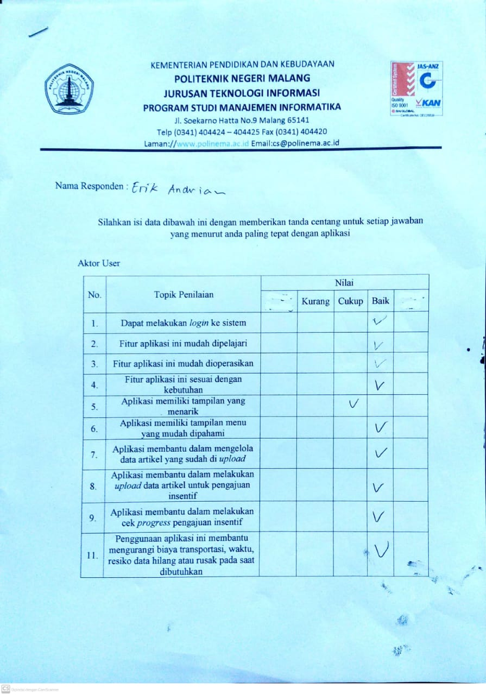

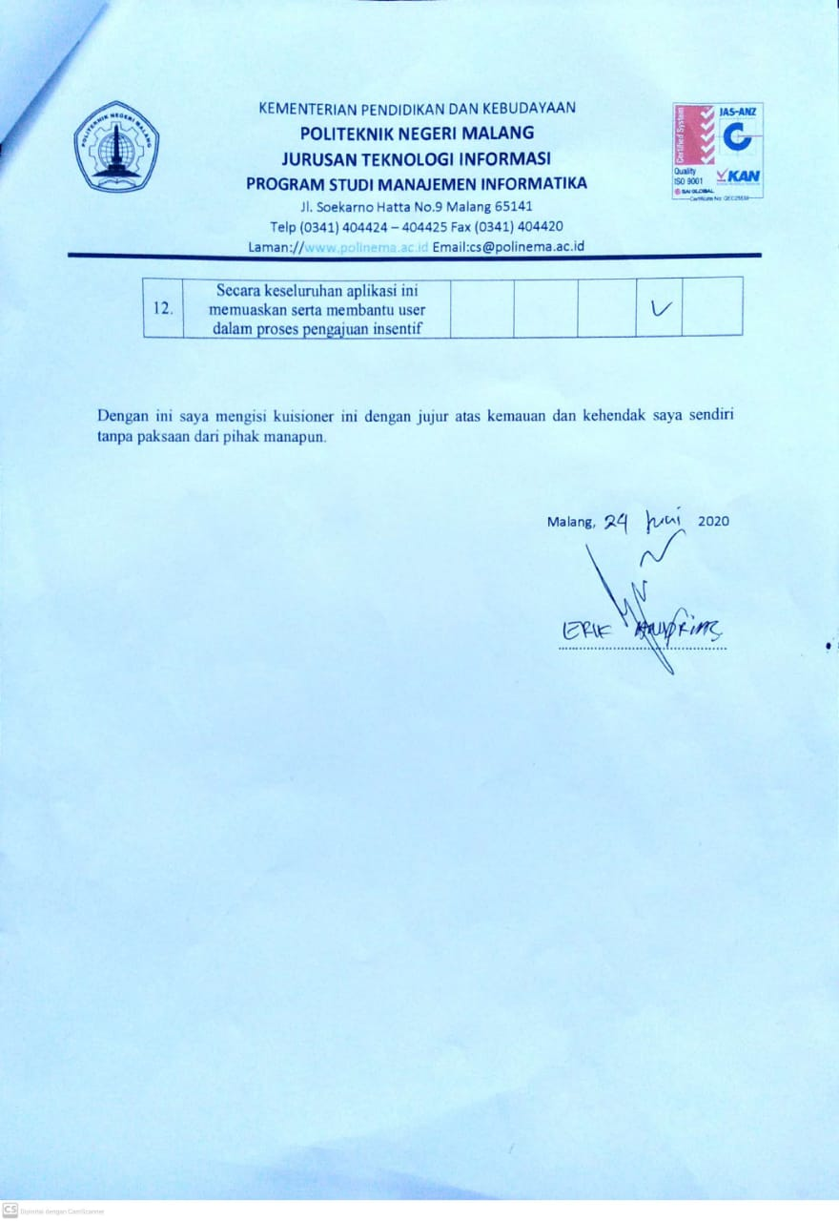

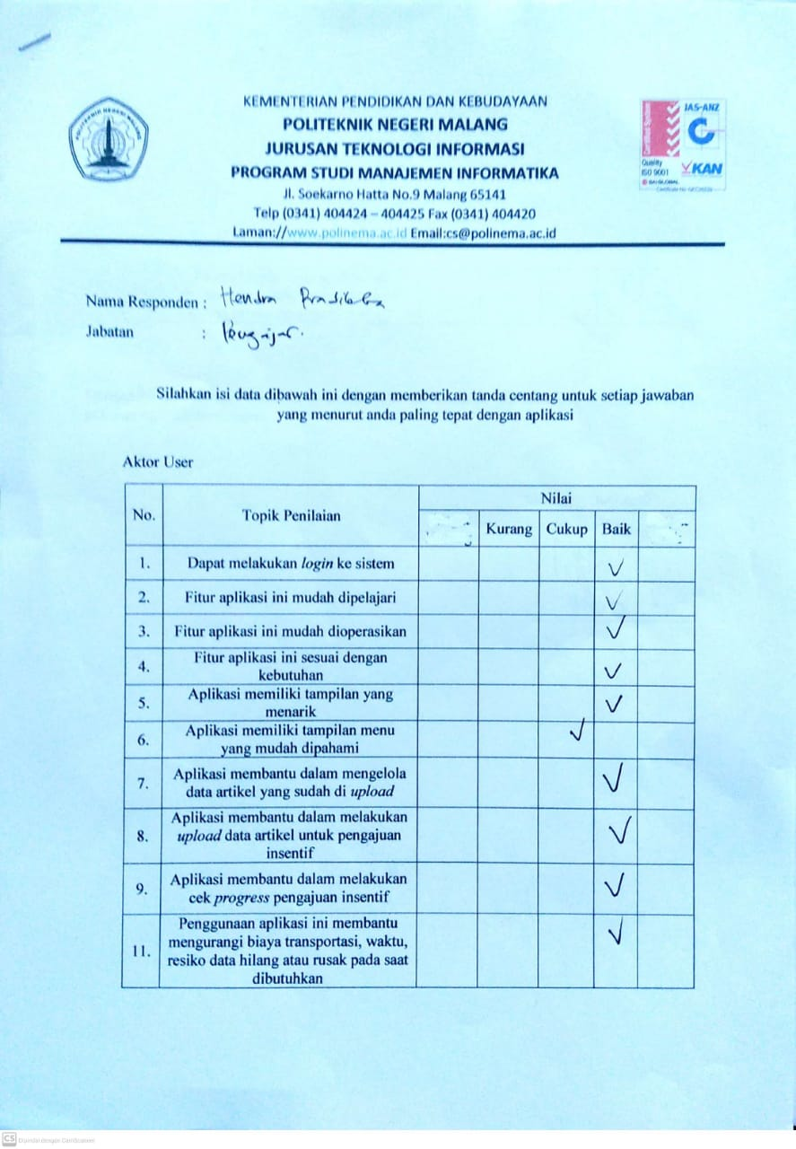

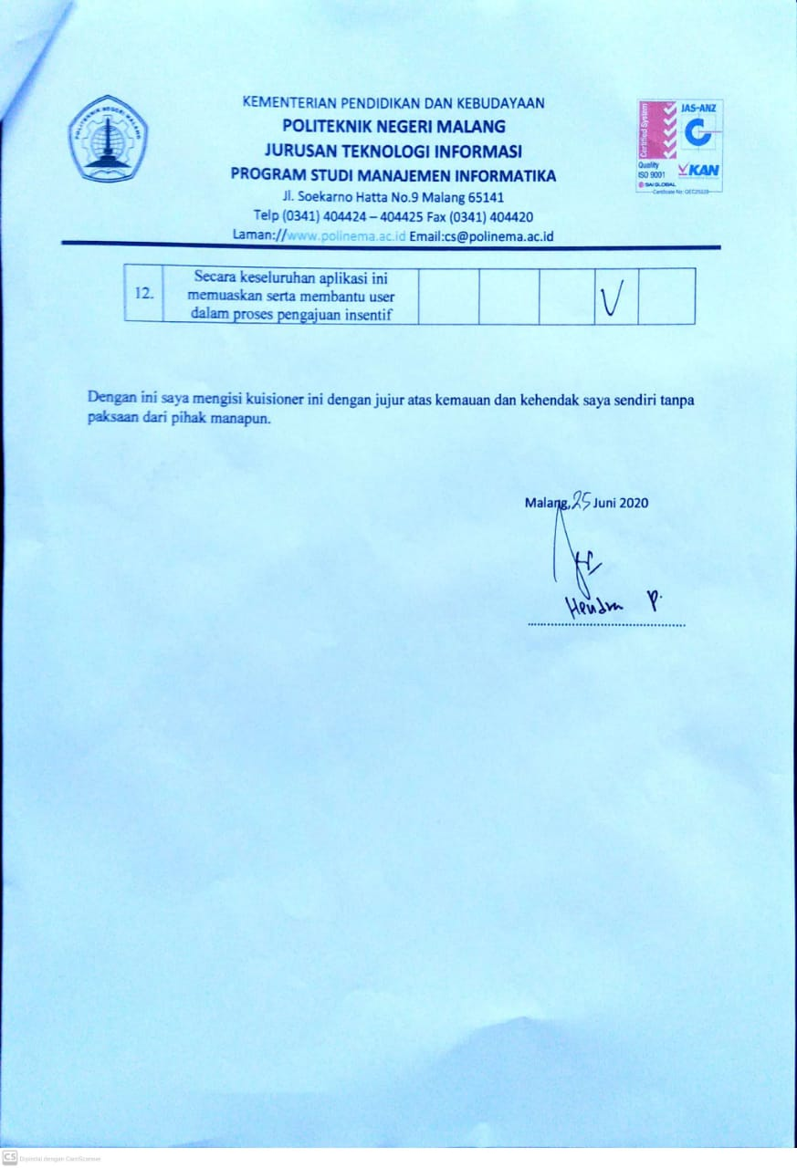

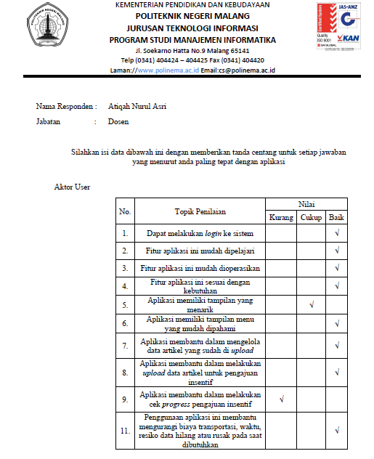

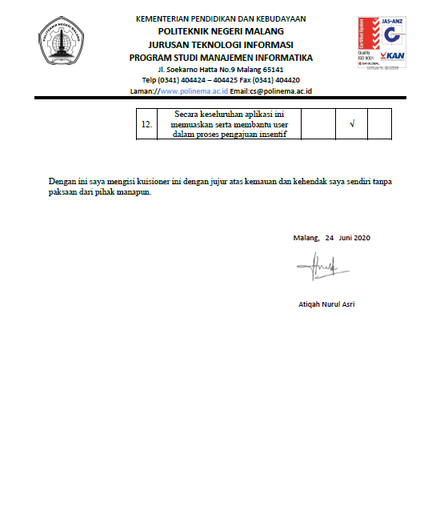

Lampiran 3: Profil Penulis

* + **Penulis 1**



Data Pribadi

Nama : Dany Kurniawan Kusumah

Tempat, Tanggal Lahir : Kediri, 13 Juli 1998

Alamat : Dsn. Jeruk Ds. Tugurejo RT.06 RW.04

Kec. Ngasem Kab. Kediri – Jawa Timur(64182)

No.Telepon : 085155248567

E-mail : [danykurniawanapk3@gmail.com](mailto:danykurniawanapk3@gmail.com)

* + **Penulis 2**



Data Pribadi

Nama : Grandis Ardana Ahmad Fahrezi

Tempat, Tanggal Lahir : Blitar, 17 November 1998

Alamat : Jln.Singajaya 002/003 Jeblog Kec.Talun

Kab. Blitar – Jawa Timur (66183)

No. Telepon : 082264409353

E-mail : [grandhabs91@gmail.com](mailto:grandhabs91@gmail.com)